**Moderate to Severe Evaluation**

Sample_id : **N7ETUV(Dog)**

Link:<https://release.animalbiome.com/pet/assessment/report/summary/d8763d1f-ac48-4109-88bc-db8dc6fcc7ea>

Cats and dogs:

Any two of the following:

(

High Red Flag Megamonas OR (failed)

High Red Flag Sutterella OR (failed)

High Red Flag Collinsella OR (failed)

Low Red Flag Bacteroides OR (**passed**)

Low Red Flag Blautia (**passed**)

);

OR

Dogs:

8 or more yellow flags (failed)

OR 8 or more red flags (failed)

High red megamonas,suttrella and collinsella failed.

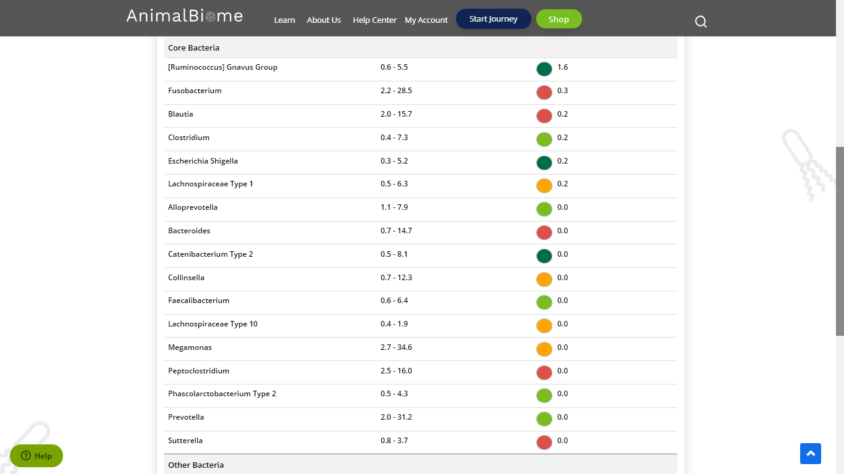

Low group evaluation:

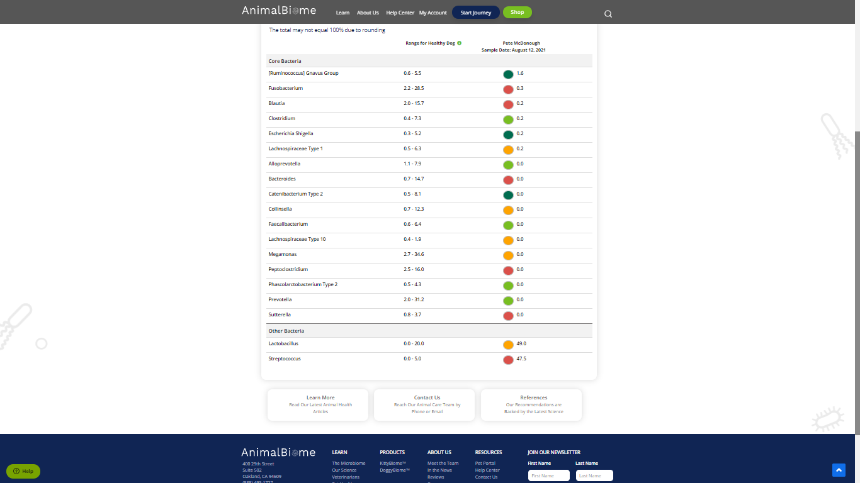

low red blautia : passed.

Low red bacteroides : passed (two conditions satisfied ) in the primary group.

Total yellow flags : 5

Red flags : 6

The result : **True False False**

Moderate to severe results:Pass

Expected result : **Moderate to severe**

Achieved result : **passed.**

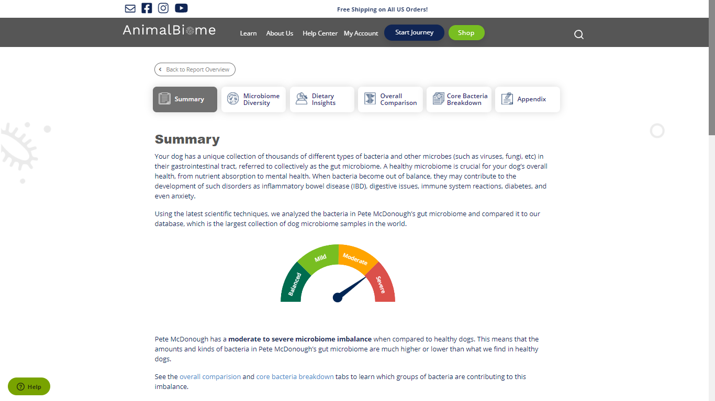

Link:<https://release.animalbiome.com/pet/assessment/report/summary/d8763d1f-ac48-4109-88bc-db8dc6fcc7ea>